SessionEstablish SD

**Abstract**

This document defines the SessionEstablish service functionality.

1. Service Description Overview

This document describes an Arrowhead service, including its interfaces, functions and information model.

The SessionEstablish Service provides two different interfaces to mediate between the Consumer and the Provider application systems with the help of a Broker and sockets.

1. Abstract Interfaces

This Service provides two functionalities.

# ConnectToConsumer

This service connects to the Broker and starts a thread, which creates general (insecure) or SSL secured sockets for the consumer System based on the instructed connection mode. It mediates between the consumer System and the Broker.

The invocation of the service triggers a session establishment procedure. During this, the gateway chooses an available port in the predefined port range. The response is this port number, which will be forward to the consumer System via the Orchestration Response. The consumer System will send its request to this port instead of the provider System’s port.

The flowchart of this service is depicted in Figure 1.

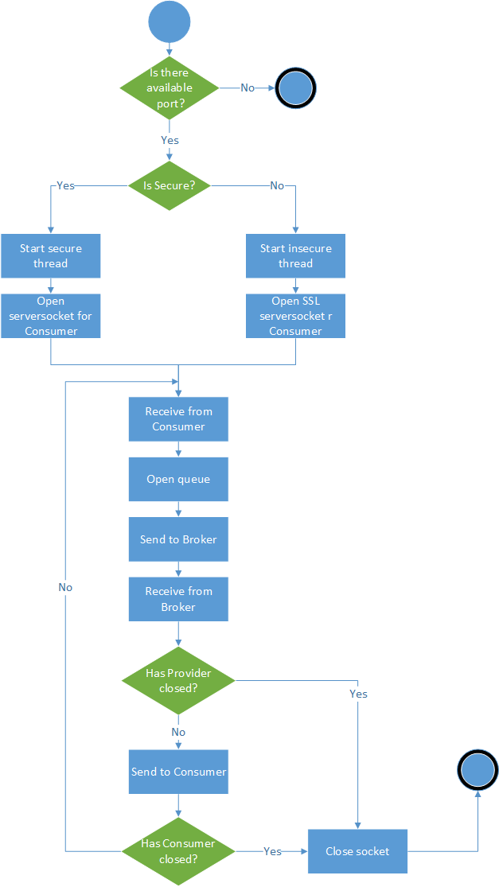

Figure 1 ConnectToConsumer flowchart

# ConnectToProvider

This interface invocation triggers a connection to the Broker and starts a new thread, which creates general or SSL sockets for the provider System based on the instructed connection mode.

It then tunnels between the provider System and the Broker. The response consists of two Strings: a RabbitMQ queueName for the general messages and one for the control messages. The flowchart of this service is depicted in Figure 2.

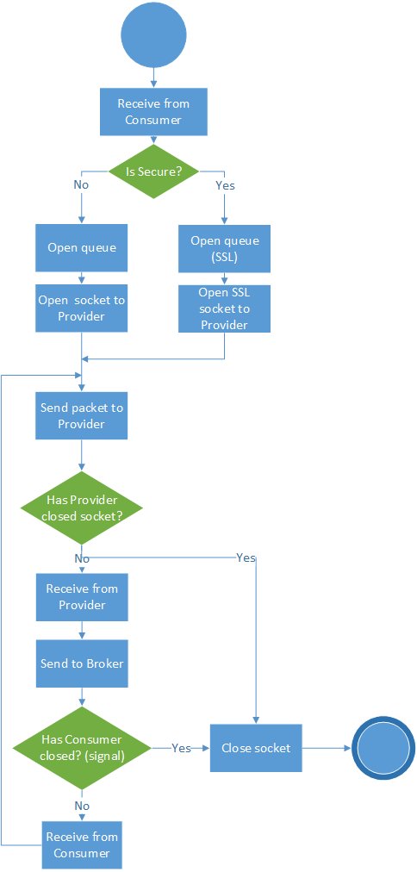

Abstract Information Model

Figure 2 ConnectToProvider flowchart

A ConnectToConsumerRequest contains the following information, as presented in Table 1.

Table 1 ConnectToConsumerRequest description

|  |  |
| --- | --- |
| **Field** | **Description** |
| brokerName: String | The name of the chosen Broker which will be used for the message forwarding. |
| brokerPort:  Integer | The port of the chosen Broker. |
| queueName:  String | The (unique) name of the declared queue, which will be used for the general message forwarding during the session. |
| controlQueueName:  String | The (unique) name of the declared queue, which will be used for the control message forwarding during the session. |
| consumer:  ArrowheadSystem | The system which requested the Service |
| provider:  ArrowheadSystem | The system which provides the Service |
| consumerCloud:  ArrowheadCloud | The Local Cloud of the consumer System |
| providerCloud:  ArrowheadCloud | The Local Cloud of the provider System |
| service:  ArrowheadService | The requested Service. |
| isSecure:  Boolean | The mode of the connection. |
| timeout:  Integer | The predefined timeout for the sockets. |
| providerGWPublicKey:  String | The public key of the provider side Gateway for the payload encryption. |

The ConnectToConsumerResponse contains the following information, as presented in Table 2.

Table 2 ConnectToConsumerResponse description

|  |  |
| --- | --- |
| **Field** | **Description** |
| serverSocketPort:  Integer | The consumer System will send its request to this chosen port instead of the provider System’s port. |

A ConnectToProviderRequest contains the following information, as presented in Table 2.

Table 3 ConnectToProviderRequest description

|  |  |
| --- | --- |
| **Field** | **Description** |
| brokerName: String | The name of the chosen Broker which will be used for the message forwarding. |
| brokerPort:  Integer | The port of the chosen Broker. |
| consumer:  ArrowheadSystem | The system which requested a Service |
| provider:  ArrowheadSystem | The system which provides the Service |
| consumerCloud:  ArrowheadCloud | The Local Cloud of the consumer System |
| providerCloud:  ArrowheadCloud | The Local Cloud of the provider System |
| service:  ArrowheadService | The requested Service. |
| isSecure:  Boolean | The mode of the connection. |
| timeout:  Integer | The predefined timeout for the sockets. |
| consumerGWPublicKey:  String | The public key of the consumer side Gateway for the payload encryption. |

A ConnectToProviderRequest contains the following information, as presented in Table 2.

Table 1 ConnectToProviderResponse description

|  |  |
| --- | --- |
| **Field** | **Description** |
| queueName:  String | The (unique) name of the declared queue, which will be used for the general message forwarding during the session. |
| controlQueueName:  String | The (unique) name of the declared queue, which will be used for the control message forwarding during the session. |

1. Revision history

# Amendments

|  |  |  |  |  |
| --- | --- | --- | --- | --- |
| No. | Date | Version | Subject of Amendments | Author |
| 1 | 2018-01-30 | 0.1 | Initial | Nikolett Szeles |
| 2 |  |  |  |  |

# Quality Assurance

|  |  |  |  |
| --- | --- | --- | --- |
| No. | Date | Version | Approved by |
| 1 |  |  |  |
| 2 |  |  |  |